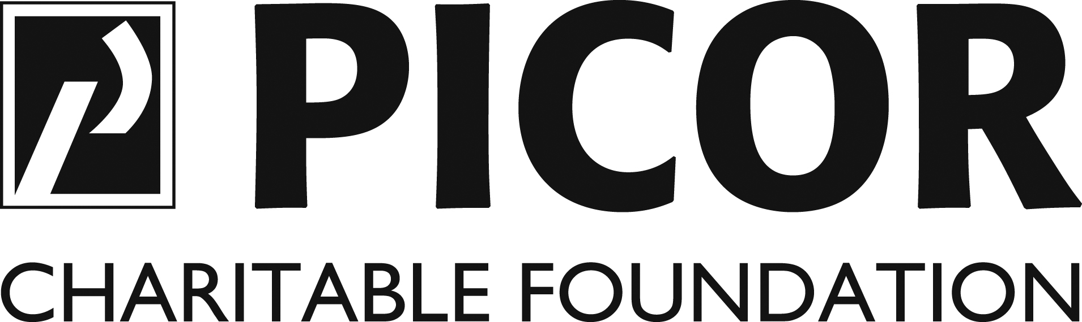

INTRODUCTION TO GRANT APPLICATION

PICOR Charitable Foundation (PCF) is a professional service organization dedicated to raising funds for distribution to not-for-profit organizations, selected by committee, whose programs and projects raise the quality of life and opportunities for underserved youth within Pima County. We are pleased to invite your organization to complete a funding request to be considered for one of PCF’s grants in the amount of $5,000. Please return your application no later than September 30th to be considered for this year’s grant cycle. Our committee makes funding decisions in November and distributes grants by mid-December each year.

You are welcome to attach supplemental information to the one-page application in a format that can easily be duplicated and shared with the Review Committee. Note that one time submission of your organization’s IRS 501(c)(3) Determination Letter is required for consideration.

Contact our Foundation Chair, Rob Tomlinson, at (520) 748-7100 with any questions. Thank you for your interest and commitment to supporting Tucson’s youth!

Please complete and mail or deliver to:

PICOR Charitable Foundation
5151 E. Broadway Blvd, Suite 115
Tucson, Arizona 85711-3780
Attention: Angie Benedict
abenedict@picor.com

(520) 748-7100 Office

GRANT APPLICATION
□ STEM Award
(Please check if you are applying for the Ken Nickel Memorial STEM Award)

PICOR Charitable Foundation
Annual Deadline: 5:00 pm September 30th
Organization Information

Organization Name
Executive Director
Office Phone E-mail
Mailing Address
City/State/Zip
Date organization started Annual organization budget $
Has your organization applied to PCF before? □ Yes □ No If yes, please indicate most recent year
Has your organization been funded by PCF before? □ Yes □ No If yes, please indicate most recent year
and the amount $
Is your organization’s IRS 501(c)(3) Determination Letter attached? □ Yes □ No*
Write a brief description (no more than 100 words) about your organization and its mission
* Letter required for consideration by PICOR Charitable Foundation

Program Information

Program name
Person with Primary Responsibility for Program
Amount requested from PCF $ * Total annual program budget $
*Maximum amount awarded $5,000
Write a brief description (no more than 150 words) about your program and how funding will be distributed.

